SCHOOLOFCOMPUTER SCIENCE AND ARTIFICIAL INTELLIGENCE |  |  |  |  | DEPARTMENT OF COMPUTER SCIENCE ENGINEERING
ProgramName: M. Tech/MCA/MSC |  |  |  | AssignmentType: Lab |  |  | AcademicYear:2025-2026
CourseCoordinatorName |  |  |  | Venkataramana Veeramsetty
CourseCode |  |  |  | CourseTitle |  | AI Assisted Problem Solving Using Python
Year/Sem |  |  | I/I | Regulation |  | R25
DateandDay  of Assignment |  |  | 08.12.2025 | Time(s)
Duration |  |  | 2 Hours | Applicableto  Batches
AssignmentNumber:19.4(Presentassignmentnumber)/24(Totalnumberofassignments)
 | Q.No. | Question |  |  |  |  |  | ExpectedTime  to complete
 | 1 | Lab 19 – Code Translation: Converting Between Programming Languages  Lab Objectives:  - Understand how AI tools can assist in translating code between different programming languages.  - Learn to verify correctness and functionality after translation.  - Explore syntactic and semantic differences between languages (e.g., Python, Java, C++).  - Practice debugging and optimizing AI-translated code.  Task 1: Translate a Simple Program (Python → JavaScript)  - Instructions:  - Write a Python function print_numbers() that prints the first 10 natural numbers using a loop.  - Translate the function into JavaScript as a reusable function printNumbers().  - Call the function in both languages to display results.  - Expected Output:  - 1  - 2  - 3  - ...10  PYTHON CODE:  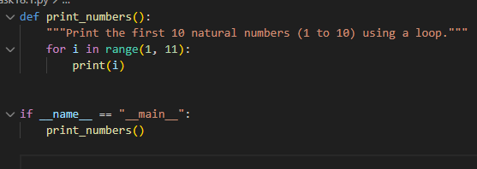  OUTPUT:  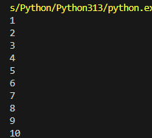  JAVA SCRIPT CODE:  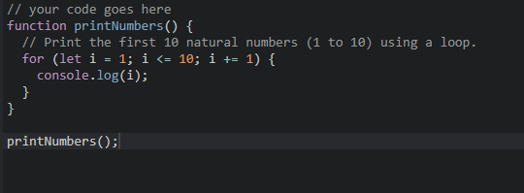  OUTPUT:  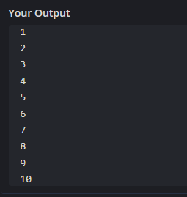  Task 2: Convert Conditional Statements (Java → Python)  - Instructions:  - Write a Java method checkNumber(int num) that checks if a number is positive, negative, or zero.  - Translate the method into a Python function check_number(num).  - Call the function/method with different inputs and compare outputs.  - Expected Output:  - Input: -5 → Output: The number is negative  - Input: 0 → Output: The number is zero  - Input: 7 → Output: The number is positive  JAVA CODE:  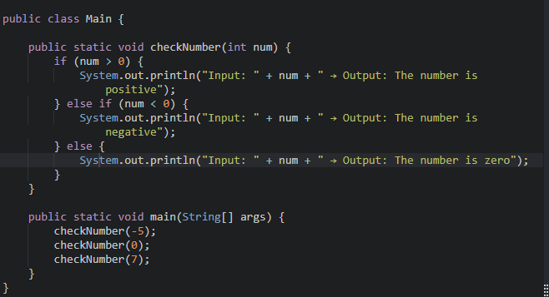  OUTPUT:  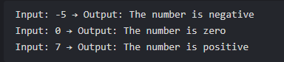  PYTHON CODE:  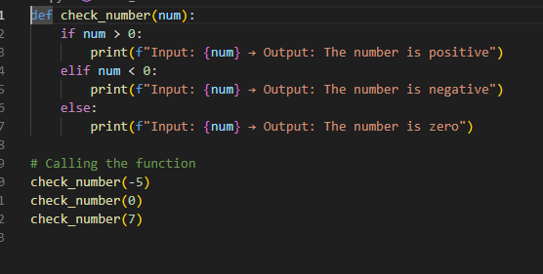  OUTPUT:  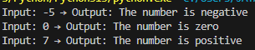  Task 3: Translate Recursive Function (Python → C++)  - Instructions:  - Write a Python function factorial(n) that calculates factorial of a number using recursion.  - Translate the same into a C++ function int factorial(int n).  - Call the function in both languages with inputs 5 and 0.  - Expected Output:  - Input: 5 → Output: Factorial = 120  - Input: 0 → Output: Factorial = 1  PYTHONCODE:  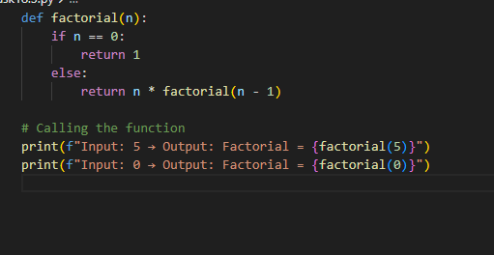  OUTPUT:  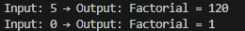  C++ CODE:  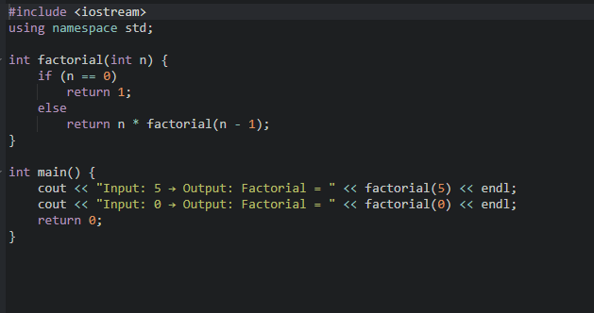  OUTPUT:  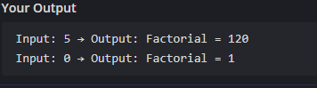  Task 4: Data Structures with Functions (JavaScript → Python)  - Instructions:  - Write a JavaScript function printStudents(students) that takes an array of student names and prints each name.  - Translate it into a Python function print_students(students) using a list.  - Test both functions with sample student names.  - Expected Output:  - Student List:  - Alice  - Bob  - Charlie  JAVA SCRIPT CODE:  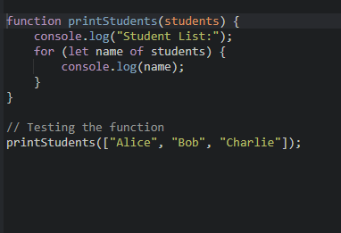  OUTPUT:  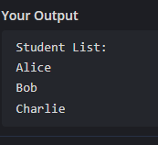  PYTHON CODE:  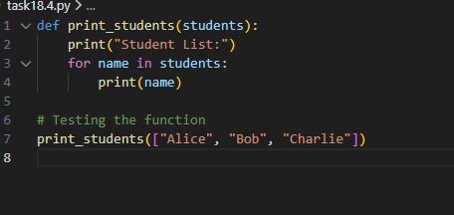  OUTPUT:  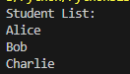  Task 5: Class & Object Translation (Python → Java)  - Instructions:  - Write a Python class Car with attributes: brand, model, year.  - Add a methoddisplay_details() that prints car details.  - Translate the same into a Java class Car with attributes and a methoddisplayDetails().  - Create an object in both languages and call the method.  - Expected Output:  - Car Details:  - Brand: Toyota  - Model: Corolla  Year: 2020  PYTHON CODE:  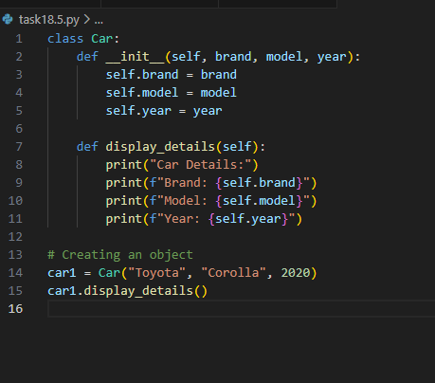  OUTPUT:  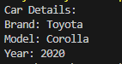  JAVA CODE:  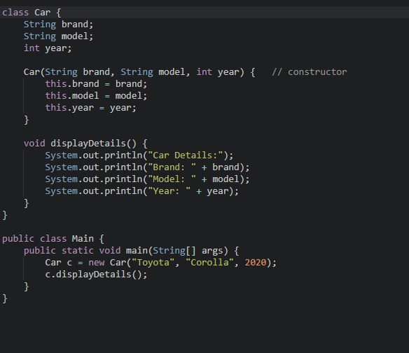  OUTPUT:  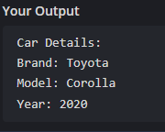  ✅ Deliverables (For All Tasks)  - AI-generated prompts for code and test case generation.  - At least 3 assert test cases for each task.  - AI-generated initial code and execution screenshots.  - Analysis of whether code passes all tests.  - Improved final version with inline comments and explanation.  - Compiled report (Word/PDF) with prompts, test cases, assertions, code, and output. |  |  |  |  |  | 08.12.2025

